Math II Exam Review 2015-2016
N.RN-2 (one question on the exam)
1. Simplify $\sqrt{45x^{2}y^{5}}$ 2. Simplify $\sqrt[3]{16x^{4}y^{2}}$

3. Simplify $\sqrt{50xy^{5}}$ 4. Simplify $\sqrt[3]{27x^{2}y^{8}}$

5. Simplify ${\left(2r^{3}\right)}^{2}$
A. $2r^{5}$ B. $2r^{6}$ C. $4r^{5}$ D. $4r^{6}$
6. Which expression is equivalent to ${\left(64x^{5}y^{3}\right)}^{\frac{1}{4}}$
A. $2x•\sqrt[4]{4xy^{3}}$ B. $4x•\sqrt[4]{4xy^{3}}$ C. $8xy•\sqrt[4]{xy}$ D. $16x•\sqrt[4]{xy^{3}}$

7. Which expression is equivalent to ${\left(4x^{3}\right)}^{\frac{1}{2}}•{\left(9x\right)}^{\frac{1}{2}}$
A. $6x^{2}$ B. $\sqrt{13x^{4}}$ C. $\sqrt{36x^{4}}$ D. $36x^{\frac{3}{4}}$

8. Simplify ${\left(16x^{5}y^{-3}z^{2}\right)}^{\frac{-1}{4}}$

9. Simplify ${\left(4x^{-3}y^{4}z^{-2}\right)}^{\frac{-3}{2}}$

10. Simplify ${\left(8w^{7}x^{-5}y^{3}z^{-9}\right)}^{\frac{-2}{3}}$

A.SSE.1a&b (two questions on the exam)
- The height in meters of a projectile involves the object’s initial height, upward velocity, and acceleration because of gravity. If the equation $y=-9.8t^{2}+109.7t+7.4$ models the number of meters, $y$, a toy rocket is above the ground $t$ seconds after being launched, what does the 7.4 represent?
- Initial height of the rocket
- Acceleration because of gravity
- Initial upward velocity of the rocket
- Total time the rocket travels after $t$ seconds

- The population of a bacteria after $x$ number of hours is modeled by the expression $1,000{\left(0.75\right)}^{x}$. What is the rate of decay of the population of bacteria?
- 25%
- 75%
- 0.75%
- 1.25%

- Which is the coefficient of the expression $-3a^{2}c^{-7}$?
- -7
- -3
- 2
- 3

- The population of a city after $x$ years is modeled by the equation $y=20000{\left(1.10\right)}^{x}.$ What does the 1.10 represent in this equation?
- The initial population of the city is 110.
- The initial population of the city is 20,000.
- The population of the city is increasing by 10% each year.
- The population of the city is increasing by 110% each year.

- Which of the following is true regarding the graph of the function $y=\frac{1}{x-3}?$
- There is an $x$-intercept at $x=3$.
- There is an $x$-intercept at $x=-3$.
- There is a vertical asymptote at $x=3$.
- There is a vertical asymptote at $x=-3.$

- The charges for renting a car from a certain rental company are given by the expression $\$2(0.36x+11d)$, where $x$ represents the number of miles driven and $d$ is the number of days for which the car has been rented. Which statement about renting a car from this company is true?
- The charges are $0.36 per mile driven and $11 per day.
- The charges are $0.72 per mile driven and $22 per day.
- The charges are $11 per mile driven and $0.36 per day.
- The charges are $22 per mile driven and $0.72 per day.

- The expression $500{\left(2\right)}^{x}$ can be used to determine the size of a population that grows over a period of time. What does the 500 represent in the expression?
- The final size of the population
- The initial size of the population
- The amount of time necessary to double
- The rate at which the population is growing

- The expression $-x^{2}+2x+3$ represents the height of a ball $x$ seconds after it was thrown. What are the zeros of the expression and what do they represent in context?

A.APR.1 (two questions on the exam)
- Simplify $2\left(x^{3}y^{2}-4x^{2}y^{2}\right)-2x(y^{2}x^{2}+3)$

- Simplify $3x\left(x^{2}y-2xy^{2}\right)-4(x^{3}y+xy^{2})$

- Simplify $4\left(x^{3}y^{2}-3x^{2}y^{2}\right)-3x(y^{2}x^{2}+2xy^{2})$

- Which expression is equivalent to $3x^{3}+5x^{2}-4x^{3}-\left(4x^{2}-7x^{3}\right)?$
- $7x^{5}$ B. $6x^{3}+x^{2}$ C. $-8x^{3}-x^{2}$ D. $-8x^{3}+9x^{2}$

- Which expression is equivalent to $\left(8x^{2}+3x+7\right)+\left(3x^{2}+x-2\right)-\left(2x+9\right)$?
- $5x^{2}+x-4$ B. $5x^{2}-x+14$ C. $11x^{2}+2x-4$ D. $11x^{2}+6x+14$

- Which expression is the product of $\left(2x-3\right)\left(4x^{2}+4x+5\right)?$
- $8x^{3}+8x^{2}+10x-15$
- $8x^{3}-4x^{2}-2x-15$
- $8x^{3}-12x^{2}+6x-15$
- $8x^{3}-20x^{2}+22x-15$

- Which polynomial is equivalent to $3b^{4}\left(6b^{3}-7b^{2}+5\right)?$
- $18b^{12}-21b^{8}+15b^{4}$
- $18b^{7}-21b^{6}+15b^{4}$
- $18b^{7}-21b^{6}+15$
- $18b^{12}-21b^{8}+15$

- Find the volume of a rectangular prism with a length (4x – 2), width of (x + 1), and height (x – 5).

- Which expression is equivalent to (x + 1)(3x – 2)(x + 4)?
  - 5x + 3
  - 3x³ - 8
  - 3x³ + 13x² + 2x - 8
  - 16x² + 2x - 8

- Which of the following is equivalent to (5t + 3)²
  - 10t + 9
  - 25t² + 9
  - 25t² + 30t + 9
  - 10t² + 30t + 9

A.APR.3 (one question on the exam)
1. Given the function $y=2x^{2}+6x-3$, list the zeros of the function and sketch the graph.

2. Sketch the graph of the function $f\left(x\right)={\left(x+5\right)}^{2}$. How many zeros does the function have? How does the multiplicity relate to the graph of the function?

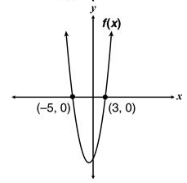
3. The function $f(x)$ opens upward, and its zeros are $-5$ and $3$. Which graph best represents $f\left(x\right)?$
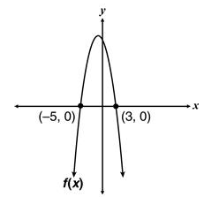
A. C.

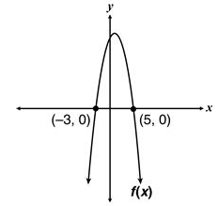
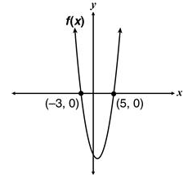
- D.

4. Which function, when graphed, would have the same zero(s) as the function below?
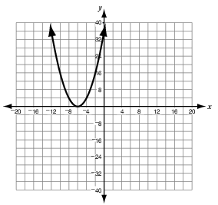

- $f\left(x\right)=x(x+6)$
- $f\left(x\right)=x(x-6)$
- $f\left(x\right)={\left(x+6\right)}^{2}$
- $f\left(x\right)={\left(x-6\right)}^{2}$

5. Based on factoring, which equation best represents the graph below?
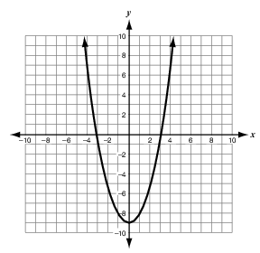
- $y=x^{2}-3$
- $y=x^{2}-9$
- $y=3x^{2}-3$
- $y=9x^{2}-1$
6. Let $p\left(x\right)=-x^{2}+5x-4$. Which statement describes the graph of $p(x)$?
A. The graph has no $x$-intercepts and opens upward from its vertex, the minimum point.
B. The graph has 2 $x$-intercepts and opens downward from its vertex, the maximum point.
C. The graph has 2 $x$-intercepts and opens upward from its vertex, the minimum point.
D. The graph has no $x$-intercepts and opens downward from its vertex, the maximum point.

7. Which of these could represent the factors of the polynomial graphed below?
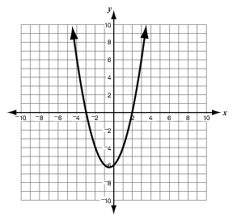
- $(x+3)(x+2)$
- $(x-3)(x-2)$
- $(x-3)(x+2)$
- $(x+3)(x-2)$

- Which of the following functions has the same set of zeros as the function $f\left(x\right)=x^{2}-6x+8?$
- $g\left(x\right)=x-4$
- $g\left(x\right)=x^{2}-5x+6$
- $g\left(x\right)=2x^{2}-12x+16$
- $g\left(x\right)=x^{2}+6x+8$
- The roots of a quadratic equation are 6 and $\frac{3}{4}$. If one of the two factors of the equation is $x-6$, what is the second factor?
- $3x-4$
- $3x+4$
- $4x-3$
- $4x+3$

A.CED.1 (two questions on the exam)
1. Karen opened a savings account with $500. The money earns 0.2% interest per month. If she does not make any withdraws or any more deposits, approximately how much money will Karen have in the account after two years?
A. $502 B. $512 C. $515 D. $525

2. A biologist predicts that the height of a certain tree will increase exponentially with time, tripling every 60 years. The tree is now 5 meters tall. According to the biologist’s prediction, in how many years would the tree become 45 meters tall?
A. 120 B. 180 C. 540 D. 800

3. Matthew can paint a room in 3 hours, while Victoria can paint an identical room in 5 hours. How long will it take them to paint both rooms at their same rates working together?
A. $1\frac{7}{8}$ hours B. $3$ hours C. $3\frac{3}{4}$ hours D. 4 hours
4. Yvette took 3 history tests. She earned grades of 87 and 92 on the first 2 tests. Her mean (average) grade for the 3 tests was 90. Which of the following equations can be used to determine her grade $G$ on the 3rd test?
A. $G=\frac{87+92}{2}$
B. $G=\frac{87+92+90}{3}$
C. $G=\frac{87+92+G}{2}$
D. $G=\frac{87+92+G}{3}$

5. A builder takes 75 days to build a house. Another builder can do the same job in 50 days. How long, in days, will it take them working together to build a house?
A. 12.5 B. 25 C. 30 D. 62.5
6. The area of a rectangular tabletop is 24 ${ft}^{2}$. The length of the table is 2 feet longer than its width. Which equation could be used to find the width ($w$) of the tabletop?
A. $24=2w+2$
B. $24=w^{2}+w$
C. $24=2w^{2}$
D. $24=w^{2}+2w$
7. A high schools chorus is planning a trip that will cost $8000. Which equation could be used to model the number of students, $x,$that need to go in order for the cost to be less than $200 per person. Assume the cost is divided evenly amongst the students who attend the trip.
A. $\frac{8000}{x}<200$ B. $\frac{200}{x}<8000$

- $\frac{x}{8000}<200$ D. $\frac{x}{200}<8000$

A.REI.2 (one question on the exam)
1. Solve: $\frac{1}{x-6}+\frac{x}{x-2}=\frac{4}{\left(x-6\right)\left(x-2\right)}$ 2. $\frac{4}{x}+\frac{1}{x^{2}}=\frac{1}{5x^{2}}$

3. $\frac{x}{x-5}+\frac{3}{x+2}=\frac{7x}{\left(x-5\right)\left(x+2\right)}$ 4. $\frac{x}{x-2}+\frac{1}{x-4}=\frac{2}{\left(x-2\right)\left(x-4\right)}$

5. $\sqrt{x-3}+5=x$ 6. $\sqrt{3x+7}=x-1$

7. $\sqrt{5x-1}+3=x$ 8. $\sqrt{x+7}-x=1$

- If the fraction $\frac{1}{2x-5}$ is equal to $\frac{1}{5}$, what is the value of $x$?

- 0 B. 2 C. 5 D. 10

- Which value or values of $x$ will make this algebraic equation true?

$$\frac{x}{x+2}-\frac{1-x}{2}=x-1$$

- $x=0$ B. $x=-1$ C. $x=-1, 2$ D. $x=\left\{all real numbers\right\}$

- During a 60-minute period, a traffic engineer counted 66 trucks and cars that crossed a bridge. The ratio of trucks to cars that travel across the bridge is usually 3:8. The equation $\frac{3}{8}=\frac{t}{66-t}$ can be used to predict the number of trucks, $t,$ the engineer should have counted. How many trucks should the engineer have counted?

- 6 B. 18 C. 22 D. 48

- What is the solution set to the rational equation $\frac{3}{x}+\frac{5}{x+2}=2$?

- $\left\{3, -1\right\}$ B. $\left\{0, 4\right\}$ C. $\left\{-0.5\right\}$ D. $\left\{-1\right\}$

- Which of the following equations is equivalent to $x-2=\sqrt{8-4x}$?

- $x^{2}-4x+4=16(2-x)$
- $x^{2}+4=8$
- $x^{2}+4x-4=8$
- $x^{2}-2^{2}=8-4x$

A-REI.4b (one question on the exam)
- Solve $3x^{2}+7x-6=0$ for $x$.
- $x=\frac{2}{3}$ or $x=3$ C. $x=-\frac{2}{3}$ or $x=3$

- $x=\frac{2}{3}$ or $x=-3$ D. $x=-\frac{2}{3}$ or $x=-3$
- What is the solution set for the following equation?
$$x^{2}-6x+9=16$$

- $\left\{-7, 1\right\}$ B. $\left\{-1, 7\right\}$ C. $\left\{3, 4\right\}$ D. $\left\{3\right\}$

- What value should be substituted for $n$ in the quadratic formula below to solve $x^{2}-5x+2=0?$
$$x=\frac{5±\sqrt{n}}{2}$$
- 2 B. 17 C. 18 D. 33

- John solved the equation $2x^{2}+x=7$ by using the quadratic formula. His work is shown below.
$$x=\frac{n±\sqrt{57}}{4}$$
What value should John substitute for $n$ found in the equation above?
- -7 B. -1 C. 1 D. 7

- What are the solutions for the equation $x^{2}-5x=6$?
- -6, 1 B. -3, -2 C. -1, 6 D. 2, 3

- What are the roots of the equation $2x^{2}+7x+4=0?$
- $\frac{-7±\sqrt{17}}{4}$ B. $\frac{-7±\sqrt{17}}{2}$ C. $\frac{7±\sqrt{17}}{4}$ D. $\frac{7±\sqrt{17}}{2}$

- The area of a square can be represented by the expression $4x^{2}-4x+1$. If the area of the square is 121 square inches, what is the value of $x$, in inches?
- 4 B. 5 C. 6 D. 11

- Solve $6x^{2}-2x-1=0$. Which of the following is the solution in the simplest form?
- $\frac{-1±2\sqrt{7}}{6}$ B. $\frac{1±2\sqrt{7}}{6}$ C. $\frac{-1±\sqrt{7}}{6}$ D. $\frac{1±\sqrt{7}}{6}$

- Which of the following quadratic functions has roots $x=3$ and $x=-1$?
- $x^{2}-2x-3$ C. $x^{2}-4x+3$
- $x^{2}+2x-3$ D. $x^{2}+4x+3$
- A ball is thrown upward from the top of a building that is 160 feet tall. The height, $h$, of the ball $t$ seconds after being thrown is given by the equation $h=-16t^{2}+48t+160$. After how many seconds will the ball hit the ground?
- 2 B. 3 C. 5 D. 10

- An equation in the form $ax^{2}+bx+c=0$ is solved by the quadratic formula. The solution to the equation is shown below.
$$x=\frac{9±\sqrt{89}}{2}$$
What are the values of $a$, $b$, and $c$ in the quadratic equation?
- $a=1, b=-9, c=2$
- $a=1, b=-9, c=-2$
- $a=1, b=9, c=2$
- $a=1, b=9, c=-2$

- Solve $x^{2}+8x=-17$ for $x$.
- $x=2, 4$
- $x=2, 9$
- $x=2, 7$
- No real solutions

A-REI.7 (one question on the exam)
- At what points do the graphs of $y=2x+1$ and $y=-{\left(x-1\right)}^{2}+3$ intersect?
- (-3, 5) and (1, 3)
- (-2, -6) and (2, 2)
- (-1, -1) and (1, 3)
- (1, 3) and (3, 7)

- What are the solutions of the system of equations $\left\{\begin{matrix}y=x^{2}-6x+8 \\ x-y=-2\end{matrix}\right.$ ?

- (5, 3) and (2, 0)
- (6, 8) and (1, 3)
- (-6, -4) and (-1, 1)
- (-5, -7) and (-2, -4)

- What are the y-coordinates of the solutions of the system of equations $5x-y=3$ and $2x^{2}+y=0?$
- -18 and $-\frac{1}{2}$ C. $-\frac{9}{2}$ and -2

- -3 and $\frac{1}{2}$ D. $-\frac{3}{2}$ and -1

- Which system of equations is represented by the graph shown below?
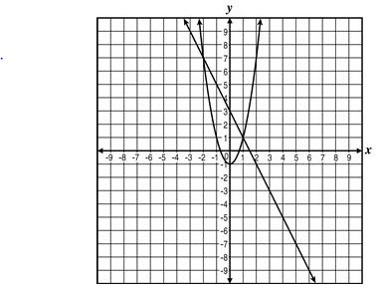
- $\begin{matrix}y=x^{2}-1 \\ 2x+y=3\end{matrix}$ C. $\begin{matrix}y=2x^{2}-1 \\ 2x+y=3\end{matrix}$

- $\begin{matrix}y=x^{2}-1 \\ 2x-y=3\end{matrix}$ D. $\begin{matrix}y=2x^{2}-1 \\ 2x-y=3\end{matrix}$

- Which point is a solution to the following system?
$$\left\{\begin{matrix}y=2{\left(x-2\right)}^{2}-3 \\ y=-2x+5\end{matrix}\right.$$

- (0, 3) B. (0, 5) C. (2, -3) D. no solution point

- A linear equation and a quadratic equation form a system and are shown in the coordinate plane below.
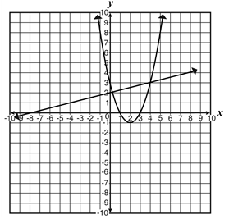
Based on the graph, which point is a reasonable solution to the system?
- (2, -1) B. (4, 3) C. (1, 0) D. (-8, 0)

- At what points does the line $y=3x-1$ intersect the circle $x^{2}+{\left(y-1\right)}^{2}=4$?

- What is the solution to the following system of equations?
$$\left\{\begin{matrix}x^{2}+y^{2}=25 \\ 4y=-3x\end{matrix}\right.$$

- Describe the possible number of solutions of a linear and quadratic system.

A-REI.10 (one question on the exam)
- The graph of $y=x^{3}$ is shown below.
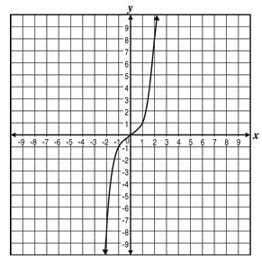
What is the approximate solution if $x=2?$
- -8 B. -1 C. 1 D. 8

- The graph of $y=-0.5x^{2}+3.5$ is shown below.
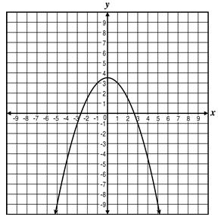
Which of the following is not part of the solution set of this equation?
- (1, 3) B. (3, 1) C. (-1, 3) D. (3, -1)

- For which of the following functions is (-1, -8) a solution?
- $5x^{2}-3x+2$
- $2x^{2}+5x-4$
- $-3x^{2}+4x-1$
- $-2x^{2}-2x+3$

- For which of the following functions is (2, 12) a solution?
A. $3x^{2}-x+2$
B. $2x^{2}-3x+4$
C. $-2x^{2}+2x-3$
D. $-3x^{2}-x+4$

- For which of the following functions is (-1, 6) a solution?
- $3x^{2}+2x-1$
- $x^{2}-5x+2$
- $2x^{2}-3x+1$
- $x^{2}+4x-5$

F-IF.2 (two questions on the exam)
- The function $C\left(n\right)=10{\left(2\right)}^{n}$ predicts the population of coyotes in an area $n$ years after 2010. What is the predicted number of coyotes in the area in 2015?
- 100 B. 270 C. 320 D. 440

- For the function $f\left(x\right)=2+x^{2}$, what is $f\left(-5\right)?$
- -27 B. -23 C. 9 D. 27

- If $f\left(x\right)=x^{2}-x$, what is $f(-3)$?
- -12 B. -6 C. 6 D. 12

- Brad threw a baseball off a cliff. The height $h$, of the ball, in feet, is modeled by the function below, where $t$ represents time, in seconds, after the ball has been thrown.
$$h\left(t\right)=-16t^{2}+48t+50$$
What is the height of the baseball after 1 second?
- 50 feet B. 66 feet C. 82 feet D. 92 feet

- Suppose $f\left(x\right)=x^{2}$ and $g\left(x\right)=2x-3$. What is the value of $g\left(4\right)+f\left(-3\right)?$
- -4 B. 7 C. 14 D. 25

- If $g\left(x\right)=x^{2}+6$, what is the value of $g\left(x+1\right)?$
- 7 B. $x^{2}+1$ C. $x^{2}+x+6$ D. $x^{2}+2x+7$

- Find the value of $k$ for $f\left(x\right)=5x^{2}+kx+2$ if $f\left(3\right)=23$.

- If $f\left(x\right)=\left\{\begin{matrix}x^{2}+1 \\ x^{3} \\ \frac{4}{x}\end{matrix} \right.\begin{matrix}x<-1 \\ -1≤x<2 \\ x≥2\end{matrix}$

Find $2f\left(-3\right)+f\left(1\right)-4f(2)$

F-IF.7e (one question on the exam)
- Which equation, when graphed, is an exponential growth function with a y-intercept at 2?

- $y=2x$ B. $y=2{\left(2\right)}^{x}$ C. $y=2{\left(0.5\right)}^{x}$ D. $y=x^{2}+2$

- Which is an equation of the function graphed below?
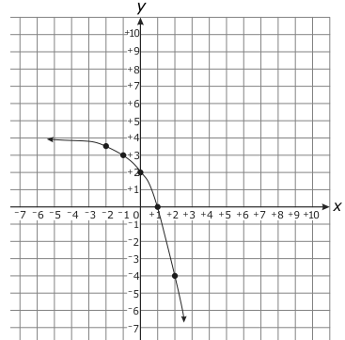

- $y=2^{x}+2$ C. $y=-2^{x}+4$
- $y=2{\left(2\right)}^{x}+2$ D. $y=-2{\left(2\right)}^{x}+4$

- Which is an equation of the function graphed below?
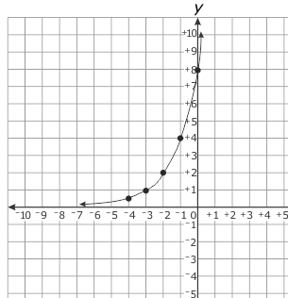
- $y=2^{(x+1)}$ C. $y=4^{\left(x+1\right)}$
- $y=2^{\left(x+3\right)}$ D. $y=4^{\left(x+2\right)}$

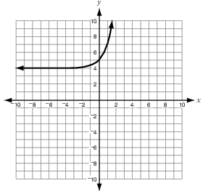
- Which graph represents the function $f\left(x\right)=3^{-x}+4?$
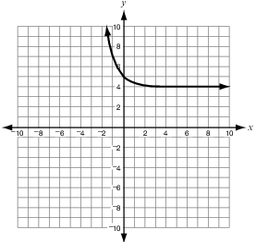
- C.

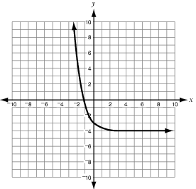
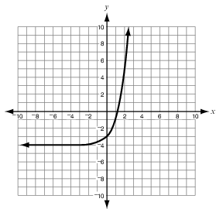
- D.

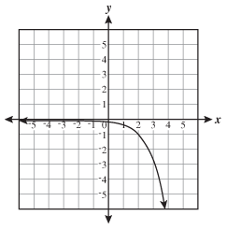
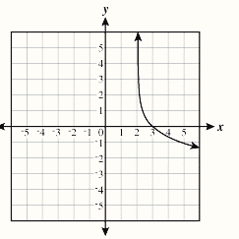
- Which graph shows the function $f\left(x\right)=-\ln\left(x-2\right)$?
- C.

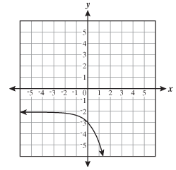
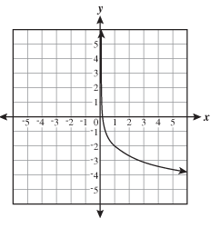
- D.

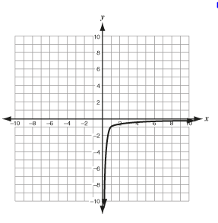
- Which graph best represents the function $f\left(x\right)=\log\left(x\right)-1?$
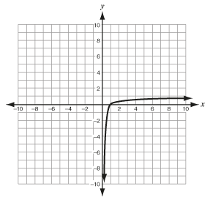
- C.

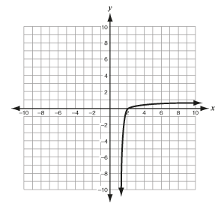
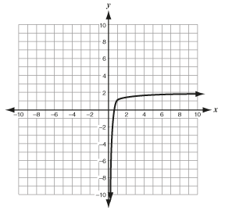
- D.

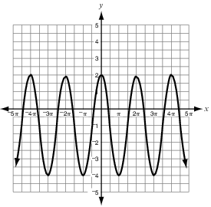
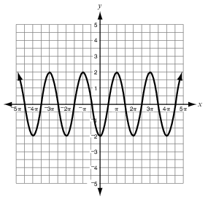
- Which graph represents a trigonometric function with an amplitude of 2?
- C.

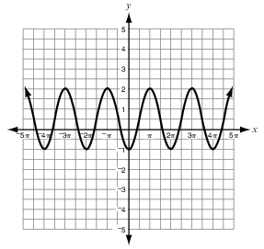
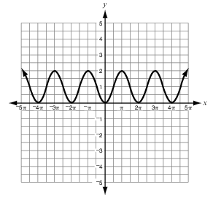
- D.

- Which describes the end behaviors of the graph of $={\left(\frac{1}{4}\right)}^{x}+2$ ?
- As $x→∞, f(x)→2$ and as $x→-∞, f(x)→∞$
- As $x→∞, f(x)→∞$ and as $x→-∞, f\left(x\right)→-2$
- As $x→∞, f\left(x\right)→-2$ and as $x→-∞, f\left(x\right)→-∞$
- As $x→∞, f(x)→∞$ and as $x→-∞, f(x)→2$

- Which graphs shows two sinusoidal functions with the same period, but with different amplitudes?
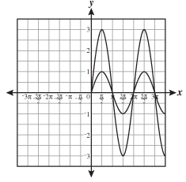
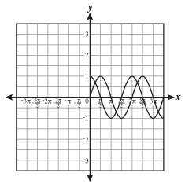
- C.

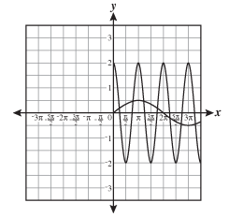
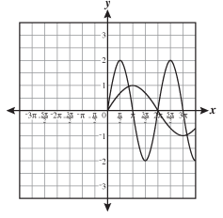
- D.

- What is the amplitude of $y=\frac{-1}{2}\cos{x}$?
- $\frac{-1}{2}$ B. $\frac{1}{2}$ C. $2$ D. $-2$
- Given the function $f\left(x\right)=2\sin{θ-3}$, which of the following is true?
- Amplitude = 3 and midline = 2
- Amplitude = -3 and midline = 2
- Amplitude = 2 and midline = 3
- Amplitude = 2 and midline = -3

F-IF.8a (two questions on the exam)
- How many times does the graph of the quadratic function $f\left(x\right)=3x^{2}-6x+3$ intersect the x-axis?
- 0 B. 1 C. 2 D. 3

- Jenny used the expression $-16x^{2}+38x+5$ to determine the height of an object $x$ seconds after it was hit into the air. How long does it take the object to hit the ground?
- $\frac{1}{8}$ second B. $\frac{2}{5}$ second C. 2.5 seconds D. 8 seconds

- Three statements about $f\left(x\right)=2{\left(x-3\right)}^{2}+5$ are given.
- The Axis of symmetry is $x=3$.
- The vertex is located at $(3, 5)$.
- The function’s minimum value is 5.
Which statement or statements are correct?
- All 3 statements
- Statement 3 only
- Statements 1 and 2
- Statements 2 and 3

- Suppose the equation $h\left(t\right)=-t^{2}+5t+14$ models the height of a ball thrown into the air off the bleachers. Which statement about the flight of the ball is true?
- The ball starts from a height of 19 feet.
- The ball takes 5 seconds before it hits the ground.
- The ball takes 14 seconds before it hits the ground.
- The ball reaches a maximum height of 20.25 feet.

- A company’s profit is described by the equation $P\left(x\right)=-5x^{2}+300x+15,000$ where $x$ is the price in dollars that the company charges for its product. What should the company charge for the product to generate the maximum profit?
- $20 B. $30 C. $50 D. $60

- A ball was kicked straight up into the air from at a velocity of 80 feet per second. The function $h\left(t\right)=-16t^{2}+80t$ models the height of the ball $t$ seconds after it was kicked. For how many seconds is the ball descending?
- 2.0 seconds B. 2.5 seconds C. 3.5 seconds D. 5.0 seconds

- Steve threw a ball into the air. The height of the ball $t$ seconds after it was thrown into the air is modeled by the function $h\left(t\right)=-16t^{2}+40t+144$. How long does it take the ball to hit the ground?
- 1.25 seconds B. 2.0 seconds C. 2.5 seconds D. 4.5 seconds

- What is the axis of symmetry of $2x^{2}-4x=y-3?$
- $x=1$ B. $x=-1$ C. $x=3$ D. $x=-3$

- The function $P\left(t\right)=-t^{2}+28t-160$ represents the profit, in thousands, of a company where $t$ is the number of years since the company started. How many years will it take till the company shows a profit?
- 8 years B. 14 years C. 20 years D. 36 years

F-IF.9 (one question on the exam)
- Maria compared the maximum value of the function $f\left(x\right)=-x^{2}+4x-1$ to the maximum value of the quadratic function that fits the values shown in the table below.

$$x$$ | $$g(x)$$
-5 | -41
-4 | -20
-3 | -5
-2 | 4

What is the value of the smaller maximum?
- -41 B. -1 C. 3 D. 7

- Joseph compared the function $f\left(x\right)=3x^{2}+2x-1$ to the quadratic function that fits the values shown in the table below.
$$x$$ | $$g(x)$$
0 | -1
1 | 8
2 | 23
3 | 44
4 | 71
Which statement is true about the two functions?
- The functions have the same y-intercept.
- The function have the same x-intercept.
- The functions have the same vertex.
- The functions have the same axis of symmetry.
- Jason compared the function $f\left(x\right)=20{\left(1.2\right)}^{x}$ to the function that fits the values in the table below.
$$x$$ | 1 | 2 | 3 | 4 | 5
$$g(x)$$ | 12 | 24 | 48 | 96 | 192

What is the distance between the y-intercepts of the two functions?
- 14 B. 8 C. 6 D. 4

- Austin and Janda threw grappling hooks into the air. The function $f\left(x\right)=-16x^{2}+32x+5$ gives the height, in feet, of Austin’s hook $x$ seconds after he threw it. The graph below shows the height, in feet, of Janda’s hook $x$ seconds after she threw it.
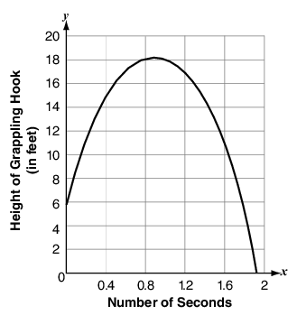
If both of them threw the grappling hooks at the same time, which of these statements is true?
- Austin’s hook hit the ground first.
- Austin’s hook reached its maximum height first.
- Austin’s hook reached a greater maximum height.
- Austin threw the hook from a greater initial height.

- A function $f(x)$ is given as $f\left(x\right)={\left(x-1\right)}^{2}+2$. The graph of the function $g(x)$ is shown below.
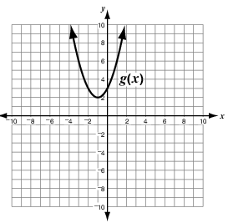
Which statement is correct?
- Both functions have x-intercepts?
- Both functions have the same y-intercept.
- Both functions have a vertex at (-1, 2).
- Both functions have an axis of symmetry at $x=1$.

- Sam compared the function $f\left(x\right)=\frac{1}{2}{\left(x\right)}^{2}$ to the table of the power function below.
$$x$$ | -1 | 0 | 1 | 2 | 3 | 4
$$g(x)$$ | -2 | 0 | 2 | 16 | 54 | 128

Which of the following is true?
- Both functions pass through the point (1, 2).
- Both functions have the same y-intercept.
- The minimum of $f(x)$ is smaller than the minimum of $g(x)$.
- The maximum of $f\left(x\right)$is greater than the maximum of $g(x)$.

- Jamie compared the function $f\left(x\right)=\frac{5}{x}$ to the inverse function in the table below.
$$x$$ | -1 | 2 | 5 | 10
$$g(x)$$ | -10 | 5 | 2 | 1

Which of the following is true?
- Both functions pass through the point (1, 1)
- Both functions have the same vertical asymptote at $x=0$.
- Both functions have the same y-intercept.
- Both functions have the same x-intercept.
F-BF.1 (two questions on the exam)
- A sequence is shown below.
-20, -17, -14, -11, -8, …
Which explicit equation could be used to determine the value of the $n$th term in the sequence?
- $a_{n}=n+3$
- $a_{n}=3n-23$
- $a_{n}=n-23$
- $a_{n}=-3n+23$

- If $f\left(x\right)=3x^{3}+6x^{2}+12x$ and $g\left(x\right)=x^{2}$, what is the product of $f(x)$ and $g(x)$?
- $3x^{3}+7x^{2}+12x$
- $3x^{6}+6x^{4}+12x^{2}$
- $6x^{3}+12x^{2}+24x$
- $3x^{5}+6x^{4}+12x^{3}$

- If $f\left(x\right)=3x-1$ and $g\left(x\right)=4x-2$, what is $h(x)$ when $h\left(x\right)=2f\left(x\right)+g(x)$?
- $h\left(x\right)=7x-3$
- $h\left(x\right)=6x-2$
- $h\left(x\right)=11x-5$
- $h\left(x\right)=10x-4$

- Suppose that two types of bacteria which coexist grow at different rates.
- The function $f\left(x\right)=2{\left(5\right)}^{x}$ models the amount of the first types of bacteria present after $x$ hours.
- The function $s\left(x\right)=3x+2$ models the amount of the second type of bacteria present after $x$ hours.
Which function, $T(x)$, models the total amount of bacteria present after $x$ hours?
- $T\left(x\right)=2{\left(5\right)}^{x}+3x+2$
- $T\left(x\right)=2{\left(5\right)}^{x}\left(3x+2\right)$
- $T\left(x\right)=\left(6x+4\right){\left(5\right)}^{x}$
- $T\left(x\right)=2{\left(3x+7\right)}^{x}$

- The weekly revenue for Ms. McConnell’s business can be estimated by the function $R\left(n\right)=30n$. The weekly costs for her business can be estimated by the function $C\left(n\right)=12n+1,500$. Which function best represents the weekly profit for this business?
- $P\left(n\right)=-18n-1,500$
- $P\left(n\right)=-18n+1,500$
- $P\left(n\right)=18n-1,500$
- $P\left(n\right)=18n+1,500$

- The first term of a sequence is 13. Each term in the sequence is 12 more than the previous term. Which explicit equation can be used to determine the $n$th term in the sequence?
- $a_{n}=n+12$
- $a_{n}=12n+1$
- $a_{n}=12n+13$
- $a_{n}=13n$

- A family wants to carpet two rooms in their home. The area of the first room can be represented by the function $f\left(x\right)=2x^{2}-7x-30$. The area of the second room can be represented by the function $g\left(x\right)=6x^{2}-11x-10$. What function, $h(x)$, shows the combined total area?
- $h\left(x\right)=8x^{2}+18x+40$
- $h\left(x\right)=8x^{2}-18x-40$
- $h\left(x\right)=8x^{2}+4x-20$
- $h\left(x\right)=8x^{2}-4x+20$

- The height, $h$, of a person varies directly with their weight, $w$, and inversely with their age, $a$. If a 22 year old person weighs 250 pounds and is 65 inch tall, which equation matches the situation?
- $h=\frac{a}{5.72w}$ B. $h=\frac{5.72w}{a}$ C. $h=\frac{a}{0.01w}$ D. $h=\frac{0.01w}{a}$

- The volume, V, of a certain gas varies inversely with the amount of pressure, P, placed on it. The volume of this gas is 175 cm³ when 3.2 kg/cm² of pressure is placed on it. What equation matches the situation?

- $V=\frac{560}{p}$ B. $V=\frac{p}{560}$ C. $V=560P$ D. $V=\frac{54.7}{p}$

- The force, F, acting on a charged object varies inversely to the square of its distance, r, from another charged object. When the two objects are 0.64 meter apart, the force acting on them is 8.2 Newtons. What equation matches the situation?

- $F=\frac{3.36}{r^{2}}$ B. $F=3.36r^{2}$ C. $F=\frac{43}{r^{2}}$ D. $F=43r^{2}$
F-BF.3 (one question on the exam)
- The function $f\left(x\right)= x^{2}$ is translated 4 units left and 2 units down. Which of the following represents the translated function?
- $x^{2}-8x+14$ C. $x^{2}+8x+14$
- $x^{2}-8x+18$ D. $x^{2}+8x+18$

- The function $f\left(x\right)= x^{2}$ is translated 2 units to the right and 3 units up. Which of the following represents the translated function?
- $x^{2}-4x-1$ C. $x^{2}+4x+7$
- $x^{2}-4x+7$ D. $x^{2}+4x-1$

- The function $f\left(x\right)=2x^{2}-4x+4$ is translated 2 units to the right and up 1 unit. Which of the following represents the translated function?

- $2x^{2}+4x+5$ C. $2x^{2}-12x+21$
- $2x^{2}+4x+4$ D. $2x^{2}+12x+21$

- The function $f\left(x\right)=3x^{2}+12x+9$ is translated 3 units to the left and down 1 unit. Which of the following represents the translated function?
- $3x^{2}+30x+71$ C. $3x^{2}-6x$
- $3x^{2}+30x+73$ D. $3x^{2}-6x+8$

- Which graph of the functions below is narrower than $f\left(x\right)=2x^{2}-1$?
- $g\left(x\right)=x^{2}-1$
- $g\left(x\right)=\frac{3}{2}x^{2}-1$
- $g\left(x\right)=2x^{2}-2$
- $g\left(x\right)=3x^{2}-1$

- The cube root function $f\left(x\right)=\sqrt[3]{x}$ is changed to $f\left(x\right)=2\sqrt[3]{x}-3$. Which statement describes how the graph of $f\left(x\right)=\sqrt[3]{x}$ will change?
- The graph will shift down 3 units and will stretch vertically by a factor of 2.
- The graph will shift down 3 units and will stretch horizontally by a factor of 2.
- The graph will shift to the left 3 units and will stretch vertically by a factor of 2.
- The graph will shift to the left 3 units and will stretch horizontally by a factor of 2.
- Which statement is true for the function $f\left(x\right)=-x^{3}+4x?$
- $f(x)$ is an even function and has end behavior such that as $x→∞, f(x)→∞$ and as $x→-∞, f\left(x\right)→∞.$
- $f(x)$ is an odd function and has end behavior such that as $x→∞, f\left(x\right)→-∞$ and as $x→-∞, f(x)→∞$.
- $f(x)$ is an odd function and has end behavior such that as $x→∞, f\left(x\right)→∞$ and as $x→-∞, f\left(x\right)→-∞.$
- $f(x)$ is an even function and has end behavior such that as $x→∞, f\left(x\right)→-∞$ and as $x→-∞, f\left(x\right)→-∞$.

- Which statement describes the translation from the graph of $y=\left|x\right|$ to the graph of $y=\left|x-1\right|-5$?
- Shift 5 units left and 1 unit down.
- Shift 5 units right and 1 unit down.
- Shift 1 unit left and 5 units down.
- Shift 1 unit right and 5 units down.

- The graph of a function is shown below.
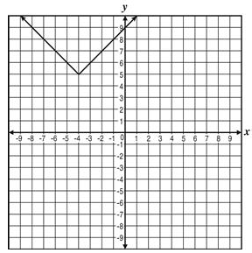

If the graph is translated 3 units right and 8 units down, what is the new equation of the function?
- $y=\left|x+4\right|+2$
- $y=\left|x+1\right|-3$
- $y=\left|x-1\right|-3$
- $y=\left|x-4\right|+2$

- The function $f\left(x\right)=x^{3}$ is transformed to $f\left(x\right)=4x^{3}$. Which statement describes the graph of the transformed function?
- The graph was stretched horizontally by a factor of 4.
- The graph was stretched vertically by a factor of 4.
- The graph was translated down by 4 units.
- The graph was translated up by 4 units.

G-CO.2 (one question on the exam)
- Which transformation changes the size of a figure?
- Dilation
- Reflection
- Rotation
- Translation

- Triangle $JKL$ below will be translated 3 units left, and 2 units down, and then reflected over the $x$-axis to form $∆J'K'L'$.
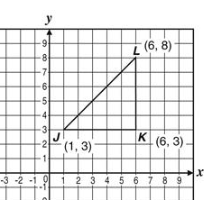
What will be the coordinates of Point $K^{'}?$
- (-3, 1) B. (-2, -1) C. (2, 1) D. (3, -1)

- Which transformation of a figure will create an image that is not congruent to the original figure?
- Dilation by a factor of 7
- Reflection about the line $y=x$
- Translation by 5 units to the left on the $x$-axis
- Rotation by 180º

- Which of the following represents the translation of Point $B$(2, 4) to Point $B'$(6, 1)?
- $(x, y)→(x-4, y+3)$
- $(x, y)→(x-3, y+4)$
- $(x, y)→(x+2, y-5)$
- $(x, y)→(x+4, y-3)$

- Which transformation does not preserve distance?
- Reflection across the x-axis
- Rotation of 90º clockwise
- Translation down 3 units
- Dilation by a factor of $\frac{3}{4}$

- The line segment $\overline{AB}$ is dilated with the center of dilation at the origin to obtain a line segment $\overline{A'B'}.$ The coordinates are $A(2, 4)$ and $A'(4, 8)$. If the coordinates of $B$ are $(x, y)$, what are the coordinates of $B'$?
- $(x+2, y+2)$
- $(x+2, 2y)$
- $(2x, 2y)$
- $(2x, y)$

- Which of the following produces congruent figures?

- $(x, y)→(x+2, 3y)$ C. $(x, y)→(2x, 2y)$
- $(x, y)→(x, 3y)$ D. $(x, y)→(x, y-3)$

G-CO.5 (one question on the exam)
- Figure 2 is a transformation of Figure 1.
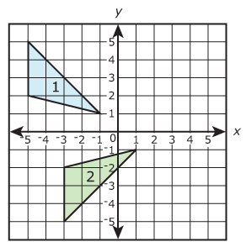
Which series of transformations map Figure 1 onto Figure 2?
- A reflection across the x-axis and a translation 2 units right.
- A reflection across the y-axis and a translation 2 units down.
- A rotation of 90º clockwise about the origin and a translation 2 units down.
- A rotation of 90º counterclockwise about the origin and a translation 2 units down.

- Figure 1 is mapped to Figure 2 under a transformation.
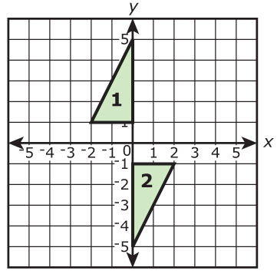
Which series of transformations maps Figure 1 onto Figure 2?
- Reflection over the y-axis and a reflection over the x-axis.
- Reflection over the y-axis and a translation of 2 units down.
- Rotation of 90º counter-clockwise around the origin and a reflection across the y-axis.
- Rotation of 90º clockwise around the origin and a translation of 2 units down.
- Which sequence of transformations will generate triangle $A'B'C'$ from triangle $ABC$?
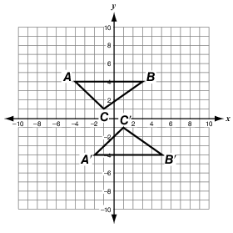
- A translation of 2 units down and then 2 units to the right.
- A reflection over the x-axis, followed by a reflection over the y-axis.
- A reflection over the x-axis, followed by a translation 2 units to the right.
- A rotation of 180º about the origin, followed by a translation 1 unit to the right.

- Which transformation could have been applied to $∆WXY$ to obtain $∆W'X'Y'$?
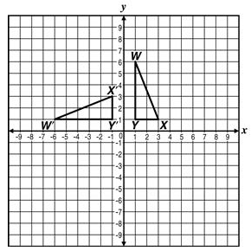
- Reflection across the y-axis.
- Reflection across the line $y=-x$.
- Clockwise rotation of 90º about the origin
- Counterclockwise rotation of 90º about the origin.

- Figure 4 is the image of Figure 1 after a sequence of transformations.
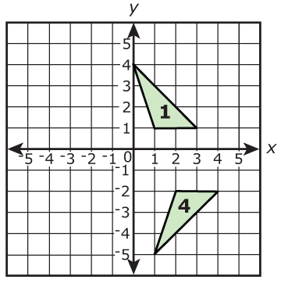
Which sequence of transformations maps Figure 1 to Figure 4?
- Reflection over the x-axis followed by a translation 1 unit right and 1 unit down.
- Reflection over the y-axis followed by a translation 3 units right and 3 units down.
- Rotation of 90º counter-clockwise around the origin followed by a reflection over the x-axis.
- Rotation of 90º clockwise around the origin followed by a translation 1 unit right and 1 unit down.

- A quadrilateral with points $A\left(1, 4\right), B\left(5, 4\right), C\left(4, 3\right),$and $D(2, 2)$ is reflected about the $y$-axis to form quadrilateral $A'B'C'D'$. Which of these sequences of transformations will also carry the quadrilateral $ABCD$ onto $A'B'C'D'$?
- Rotating the quadrilateral 90º clockwise about the origin and then reflecting it across the x-axis.
- Rotating the quadrilateral 180º about the origin and then reflecting it across the x-axis.
- Rotating the quadrilateral 90º counterclockwise about the origin and then reflecting it across the line $y=x$.
- Rotating the quadrilateral 180º about the origin and then reflecting it across the line $y=x$.

- Which transformations describes how $∆ABC$ was moved to create $∆A'B'C'$ in the picture below?
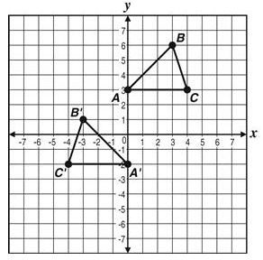
- Translation 5 units down and 1 unit to the right.
- Translation 5 units down and 4 units to the left.
- Reflection across the y-axis and translation 5 units down.
- Reflection across the x-axis and clockwise rotation of 90º

- The translation $(x, y)→(x-2, y+4)$ maps $∆ABC$ onto $∆A'B'C'$. What translation maps $∆A'B'C'$ onto $∆ABC?$
- $(x, y)→(x+2, y+4)$ C. $(x, y)→(x-2, y+4)$
- $(x, y)→(x+2, y-4)$ D. $(x, y)→(x-2, y-4)$

G-SRT.7 (one question on the exam)
- Which equation shows a correct relation for triangle $RSQ$?
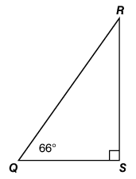
- $\sin\left(Q\right)=\sin\left(R\right)$
- $\sin\left(Q\right)=\cos\left(R\right)$
- $\tan\left(Q\right)=\cos\left(R\right)$
- $\tan\left(Q\right)=\sin\left(R\right)$

- For which value of $θ$ is the statement $\sin{{40}^{o}=\cos{θ}}$ true?
- 40º B. 50º C. 60º D. 140º

- Triangle $LMN$, shown below, is a right triangle.
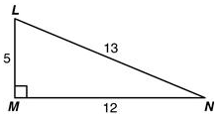
Which of the following is equivalent to $\sin{L}$?
- $\cos{L}$ B. $\tan{L}$ C. $\sin{N}$ D. $\cos{N}$

- If $\cos\left(a\right)=\sin\left({32}^{o}\right)$, what is the value of $a$?
- 32º B. 58º C. 148º D. 328º

- If $\sin\left(x\right)=\cos\left(y\right)$, which of these are possible value of $x$ and $y$?
- $x=0$ and $y=0$
- $x=15$ and $y=30$
- $x=30$ and $y=60$
- $x=120$ and $y=60$

- If $\sin\left(2x\right)=\cos\left(x+{30}^{o}\right)$, what is the value of $x$?
- 20º B. 30º C. 50º D. 110º

- In $∆WXY$, $<Y$ measures 90 degrees. Which statement must be true?
- $\cos\left(W\right)=\tan\left(X\right)$
- $\cos\left(W\right)=\tan\left(W\right)$
- $\sin\left(X\right)=\cos\left(X\right)$
- $\sin\left(X\right)=\cos\left(W\right)$

G-SRT.8 (three questions on the exam)
- What is the length of $\overline{LM}$ in the right triangle below?
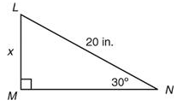
- $20\sqrt{3}$ inches
- $10\sqrt{3}$ inches
- $15$inches
- $10$inches

- Brad stands 30 feet from a tree. He estimates the angle of elevation from a point on the ground 30 feet from the tree to the top of the tree to be 60º as shown below.
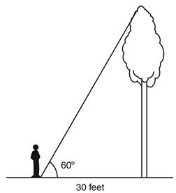
Which of the following is closest to the height of the tree?
- 15 feet B. 30 feet C. 52 feet D. 60 feet

- The dimensions of the right triangle shown below are given in units.
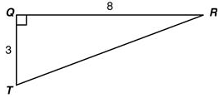
Which measurement is the closest to $m<RTQ$?
- 20.6º B. 22.0º C. 68.0º D. 69.4º

- A 10-foot ladder is placed against a building so that the ladder makes a 78º angle with the ground. To the nearest tenth of a foot, at what height does the ladder touch the building?
- 7.8 feet B. 9.8 feet C. 10.2 feet D. 16.2 feet

- In $∆XYZ, <Z$ is a right angle and $m<X={53}^{o}$. Which statement is true?
- ${\cos{53}}^{o}=\frac{YZ}{XY}$
- $\tan{{53}^{o}=\frac{XZ}{XY}}$
- $\cos{{37}^{o}=\frac{YZ}{XY}}$
- $\sin{{37}^{o}=\frac{XZ}{YZ}}$

- A man looks up at a flock of geese. If the birds are 75 feet horizontally away from the man and 40 feet in the air, what is the angle of elevation?
- 28⁰ B. 42⁰ C. 57º D. 62º
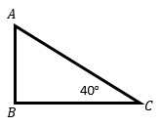
- For the triangle at the right, which of the following represents $\overline{AC}?$
A. $\frac{\sin{(40)}}{AB}$ C. $\frac{AB}{\sin{(40)}}$
B. $\frac{\cos{(40)}}{BC}$ D. $\frac{AB}{\cos{(40)}}$

- Find the value of $x$ if the perimeter is 24.

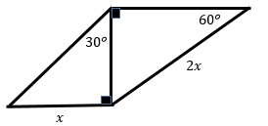

G-GPE.1 (one question on the exam)
- Given a circle with the equation ${\left(x-2\right)}^{2}+{\left(y+6\right)}^{2}=36$, which of the following represents the center and radius of the circle?
- Center (-2, 6); radius = 6
- Center (2, -6); radius = 6
- Center (-2, 6); radius = 36
- Center (2, -6); radius = 36

- What is the equation of the circle with a radius 9 and center (-5, 3)?
- ${\left(x-5\right)}^{2}+{\left(y+3\right)}^{2}=9$
- ${\left(x+5\right)}^{2}+{\left(y-3\right)}^{2}=9$
- ${\left(x-5\right)}^{2}+{\left(y+3\right)}^{2}=81$
- ${\left(x+5\right)}^{2}+{\left(y-3\right)}^{2}=81$

- Which equation is represented by the figure on this graph?
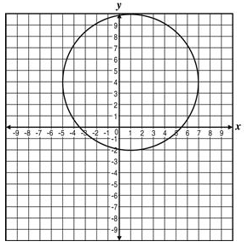

- ${\left(x-1\right)}^{2}+{\left(y-4\right)}^{2}=6$
- ${\left(x+1\right)}^{2}+{\left(y+4\right)}^{2}=6$
- ${\left(x+4\right)}^{2}+{\left(y+1\right)}^{2}=36$
- ${\left(x-1\right)}^{2}+{\left(y-4\right)}^{2}=36$

- What is the equation of a circle with radius $\sqrt{5}$ and center $\left(5, 0\right)$?
- ${\left(x-5\right)}^{2}+y^{2}=\sqrt{5}$
- ${\left(x+5\right)}^{2}+y^{2}=\sqrt{5}$
- ${\left(x-5\right)}^{2}+y^{2}=5$
- ${\left(x+5\right)}^{2}+y^{2}=5$

G-GMD.4 (one question on the exam)
- A regular hexagonal pyramid is cut horizontally by a plane.

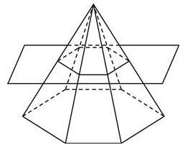
Which is the best description of the smaller pyramid on the top of the surface of the plane?
- A similar triangular pyramid.
- A smaller triangular pyramid.
- A similar hexagonal pyramid.
- A congruent hexagonal pyramid.

- A cylinder is cut into two equal sections by making a vertical cut as shown below.
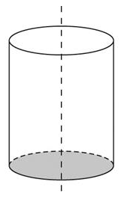
What is the shape of the cross section formed by the vertical cut?
- Circle
- Ellipse
- Square
- Rectangle, but not a square

- What is the shape of the cross section when a sphere is divided into two equal parts?
- Circle
- Semicircle
- Ellipse
- Sphere

- What shape is formed if $∆ABC$ shown below is rotated in a three-dimensional plane around the x-axis?
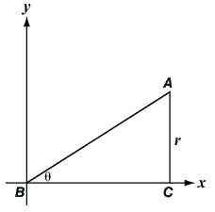
- A cone with vertex $A$
- A cone with vertex $B$
- A triangular pyramid with vertex $A$
- A triangular pyramid with vertex $B$

- James rotated a rectangle 360⁰ around one of its longest sides. Which choice could be the resulting solid?
A. Cone B. Cylinder C. Sphere D. Pyramid

- A cone of finite height is intercepted by a plane as shown below.
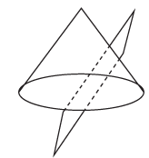
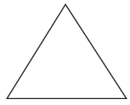
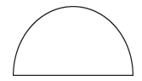
Which shape represents the cross-section?
- C.

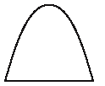
- D.

G-MG.1 (one question on the exam)
- Which geometric shape would be the best mathematical model for the truck of a tree?
- A cone
- A cylinder
- A triangular prism
- A rectangular prism

- The figure below shows a compost bin.
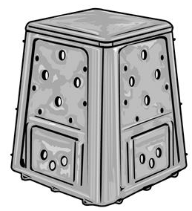
Which process is most likely to be used to estimate the total surface area of the compost bin?
- Computing the area of 6 rectangles
- Computing the area of 4 trapezoids and 2 rectangles
- Finding the perimeter of the base and multiplying by the height
- Finding the mean of the perimeters of the base and the top and multiplying by the height

- A model of an object is made of two geometric figures. Which object can be best modeled by a cylinder and a cone?
- A human torso
- An ice cream cone
- A camera with lens
- A sharpened pencil
S-IC.2 (one question on the exam)
- A spinner is divided into 4 equal sectors that are colored green, red, yellow, and blue. The number of times the spinner lands on each color is listed below.
Color | Number of Times
Green | 5
Red | 8
Yellow | 6
Blue | 6

Which statement best explains whether the results listed in the table should cause the probability model for the given situation be questioned?
- The probability model should not be questioned because the results in the table match the theoretical probability of the events occurring.
- The probability model should not be questioned because the results in the table are close enough to the theoretical probability given the number of trails.
- The probability model should be questioned because the results in the table match the theoretical probability of the events occurring.
- The probability model should be questioned because the results in the table do not match the theoretical probability of the events occurring.
- Lincoln performed an experiment with a fair spinner where he compared the theoretical probability with the experimental probability. The spinner was divided into eight congruent sections, as shown below.
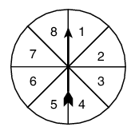
After 100 spins, Lincoln calculated the probability that he would spin a prime number to be 0.35. Using the spinner, what is the theoretical probability of spinning a prime number?
- 0.15 B. 0.35 C. 0.50 D. 0.65

- Rachel flips a coin 150 times and finds that the probability of the coin landing heads up is $\frac{1}{2}$. Rachel wants to flip the same coin 15 more times. On the first 14 flips, the coin lands heads up. Which statement best describes the probability of the coin landing heads up on the 15th flip?
- The probability of the coin landing heads up is $\frac{1}{15}$.
- The probability of the coin landing heads up is $\frac{1}{2}$.
- The probability of the coin landing heads up is $\frac{14}{15}$.
- The probability of the coin landing heads up is 1.

- Kim tosses a coin multiple times and records the outcomes. Which statement is always true?
- For the first two tosses, the experimental probability of the coin landing heads up will be different from the theoretical probability.
- For the first 10 tosses, the experimental probability of the coin landing heads up will be less than the theoretical probability.
- As the number of tosses increases, the difference between the experimental and theoretical probabilities increases.
- As the number of tosses increases, the difference between the experimental and theoretical probabilities decreases.

- A color wheel with red, green, and blue sections that have an equal probability of being landed on. After being spun 50 times, the spinner landed on red 18 times, green 17 times, and blue 15 times. What is the experimental probability of landing on red?
- $\frac{9}{25}$ B. $\frac{1}{3}$ C. $\frac{3}{10}$ D. $\frac{17}{50}$

S-CP.1 (one question on the exam)
- Suppose $S=\left\{-2, -1, 0, 1, 2\right\}$ and $T=\left\{0, 1, 2, 3, 4\right\}$. Which set represents $S∩T$?
- $\left\{3, 4\right\}$
- $\left\{0, 1, 2 \right\}$
- $\left\{-2, -1\right\}$
- $\left\{-2, -1, 0, 1, 2, 3, 4\right\}$

- Using the Venn diagram below, what is the complement of set A
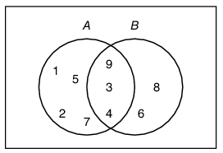
- $\left\{6, 8\right\}$
- $\left\{3, 4, 9\right\}$
- $\left\{1, 2, 5, 7\right\}$
- $\left\{3, 4, 6, 8, 9\right\}$

- If a spinner has eight sections numbered 1 to 8, which of the following events are disjoint?
Event A: Spin a 3
Event B: Spin an even number
Event C: Spin a multiple of 3
Event D: Spin a number greater than 2

- Events A and B
- Events B and C
- Events C and D
- Events B and D

- Which shaded part best represents $A∩B$?
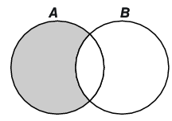
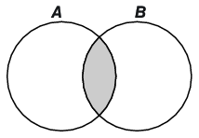
- C.

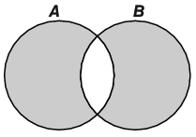
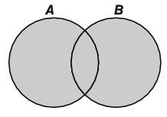
- D.

- A survey was conducted to find what percentage of high school students prefer watching baseball or football or both. Students had to select one of those three options. Let A represent the set of students who prefer watching baseball and B represent the set of students who prefer watching football.

Which statement correctly describes the complement of set A?
- The students who prefer only baseball.
- The students who prefer football but not baseball.
- The students who prefer baseball or football or both.
- The students who prefer only baseball or football.
S-CP.9 (one question on the exam)
- In gym class, 14 students are going to play basketball. Charles is selected as team captain and will choose 6 more students for his team before the other team or team captain is chosen. In how many ways can a team of 7 be chosen given that Charles must be one of them?
- 720
- 1716
- 3432
- 5040

- A bag contains 6 different colored chips. If 2 chips are selected at random, how many different combinations of colors are possible?
- 8
- 15
- 30
- 720

- Ms. Landrum’s homeroom class needs to select a president, secretary, and treasurer. If there are 21 students in the class, how many different choices of the three officers can be made?
- 63
- 441
- 7980
- 9261

- How many different ways can the letters M, T, V, and W be arranged?
- 4
- 8
- 16
- 24

