WSE Cheer Tshirt Fundraiser
Order Form
Tshirts are available in white (shown) or black. There is also a short sleeve or long sleeve option. Cash or checks (written to WSE) are due by September 23.
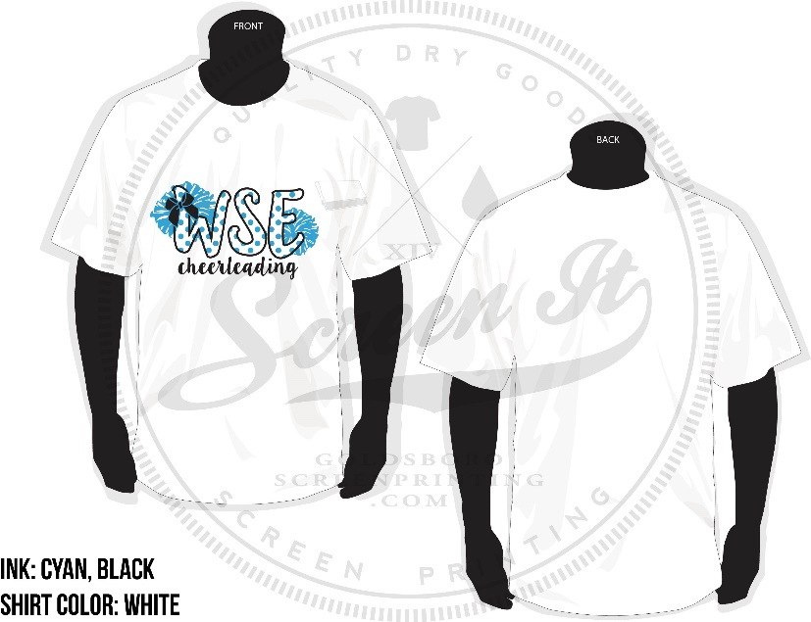

Name _____________________________________________________________

Size | BLACK  short sleeve $15 | BLACK  long sleeve $20 | WHITE  short sleeve $15 | WHITE  long sleeve $20
Youth Small
Youth Medium
Youth Large
Youth XL
Adult Small
Adult Medium
Adult Large
Adult XL
Adult 2XL (add $2)
Adult 3XL (add $3)
TOTAL

GRAND TOTAL $_______________

