WSE Cheer Tshirts 2016 – 2017

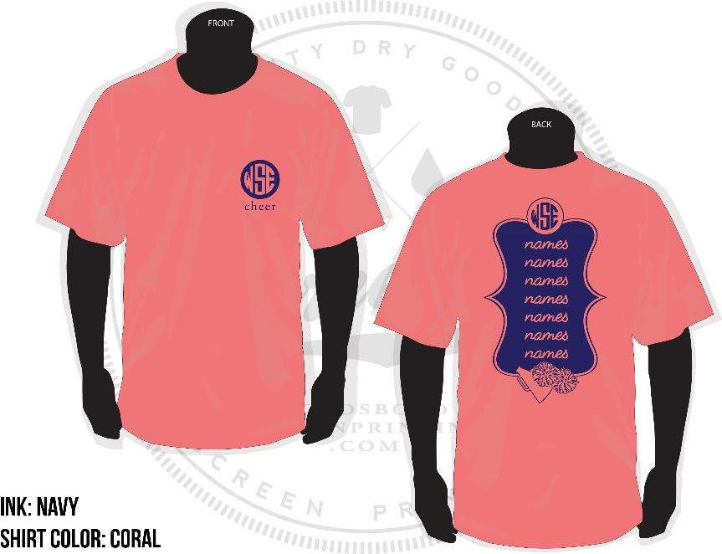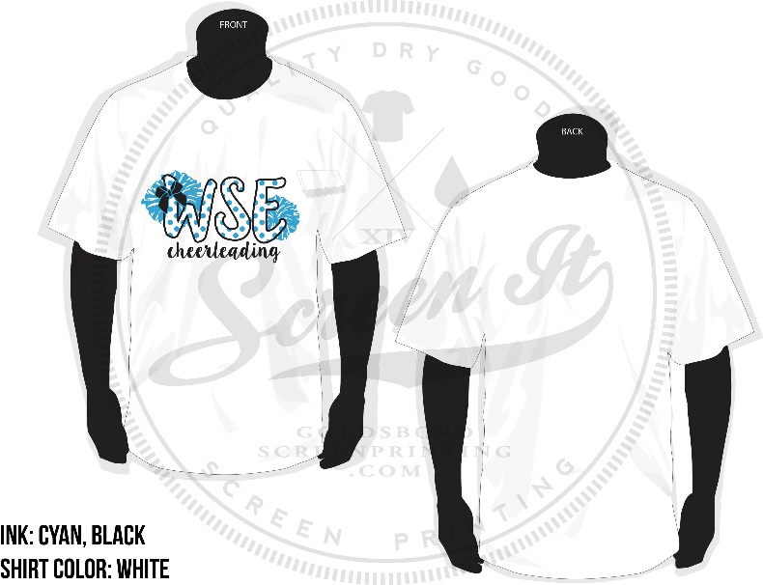

Description | Price
Names Tshirt (Coral)  Short Sleeve Only | $12
WSE Cheer Tshirt (White or Black)  Short Sleeve | $10
WSE Cheer Tshirt (White or Black)  Long Sleeve | $15

Cheerleaders need to purchase 1 Names Tshirt and 1 WSE Cheer Tshirt (choose between white/black and long/short sleeves). Returning cheerleaders only need to purchase the Names Tshirt.

Family and friends wanting to support the WSE Cheerleaders may purchase a WSE Cheer Tshirt (choose between white/black colors) for a fundraising price of $15 for short sleeves and $20 for long sleeves.

